Homework 1
2.20.
Code:
#include <iostream>
using namespace std;

int main() {
int r; //半徑
int pi = 3.14159;// π
cout << "輸入直徑 : ";
cin >> r;
cout << "直徑 : " << 2*r << endl;
cout << "周長 : " << 2*pi*r << endl;
cout << "面積 : " << pi*r*r << endl;
}
Display:
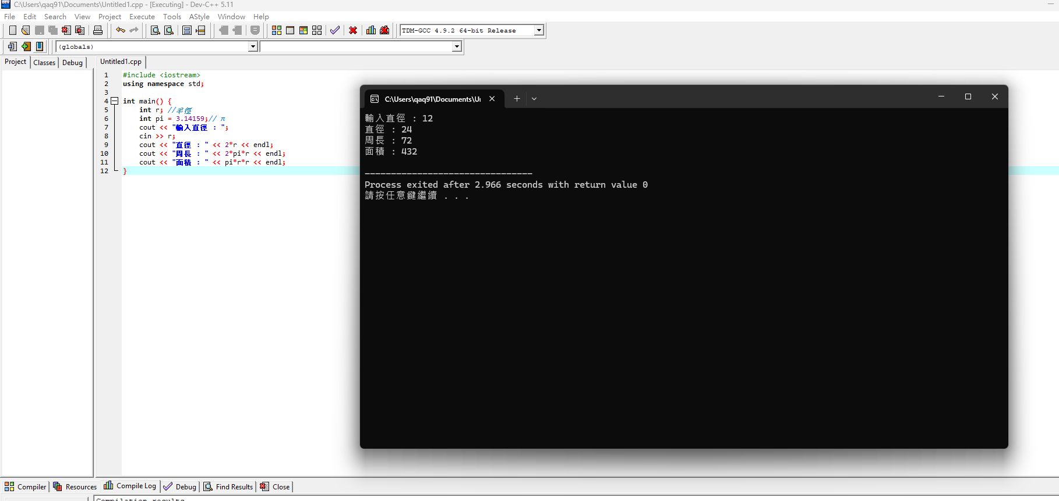

2.24.
Code:
#include <iostream>
using namespace std;

int main() {
int x; //整數
cout << "輸入整數 : ";
cin >> x;
if (x%2==0)
{
cout << "偶數" << endl;
}
else
{
cout << "奇數" << endl;
}

}
Display:
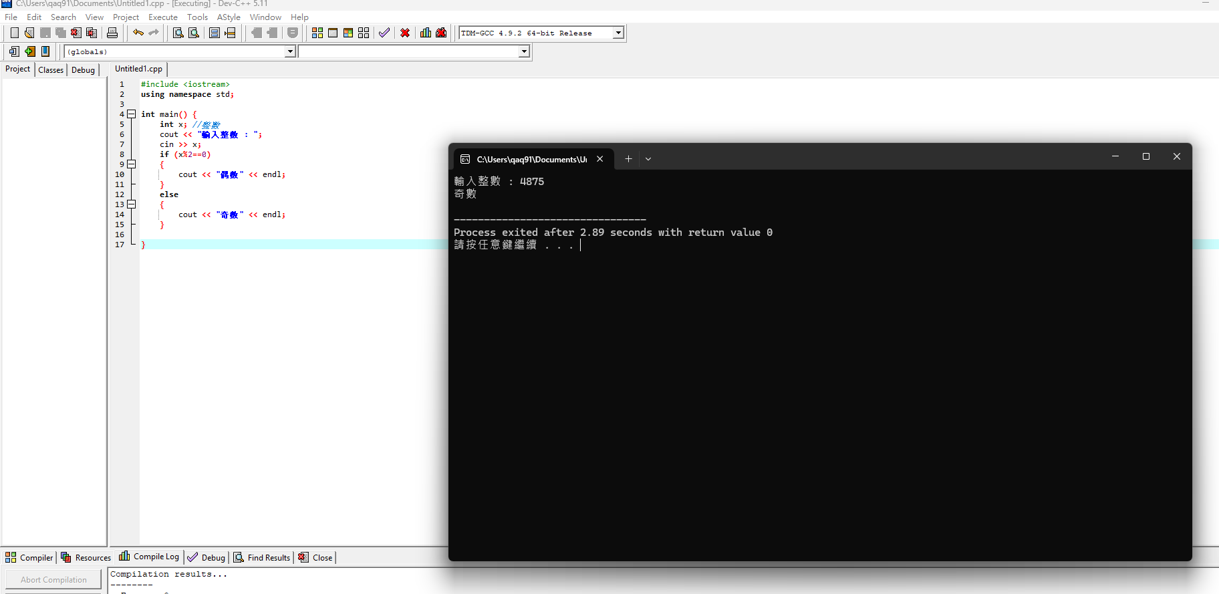

2.25
Code:
#include <iostream>
using namespace std;

int main() {
int x,y; //整數
cout << "輸入整數x : ";
cin >> x;
cout << "輸入整數y : ";
cin >> y;
if (x%y==0)
{
cout << "兩者是倍數關係" << endl;
}
else
{
cout << "兩者不是倍數關係" << endl;
}

}
Display:
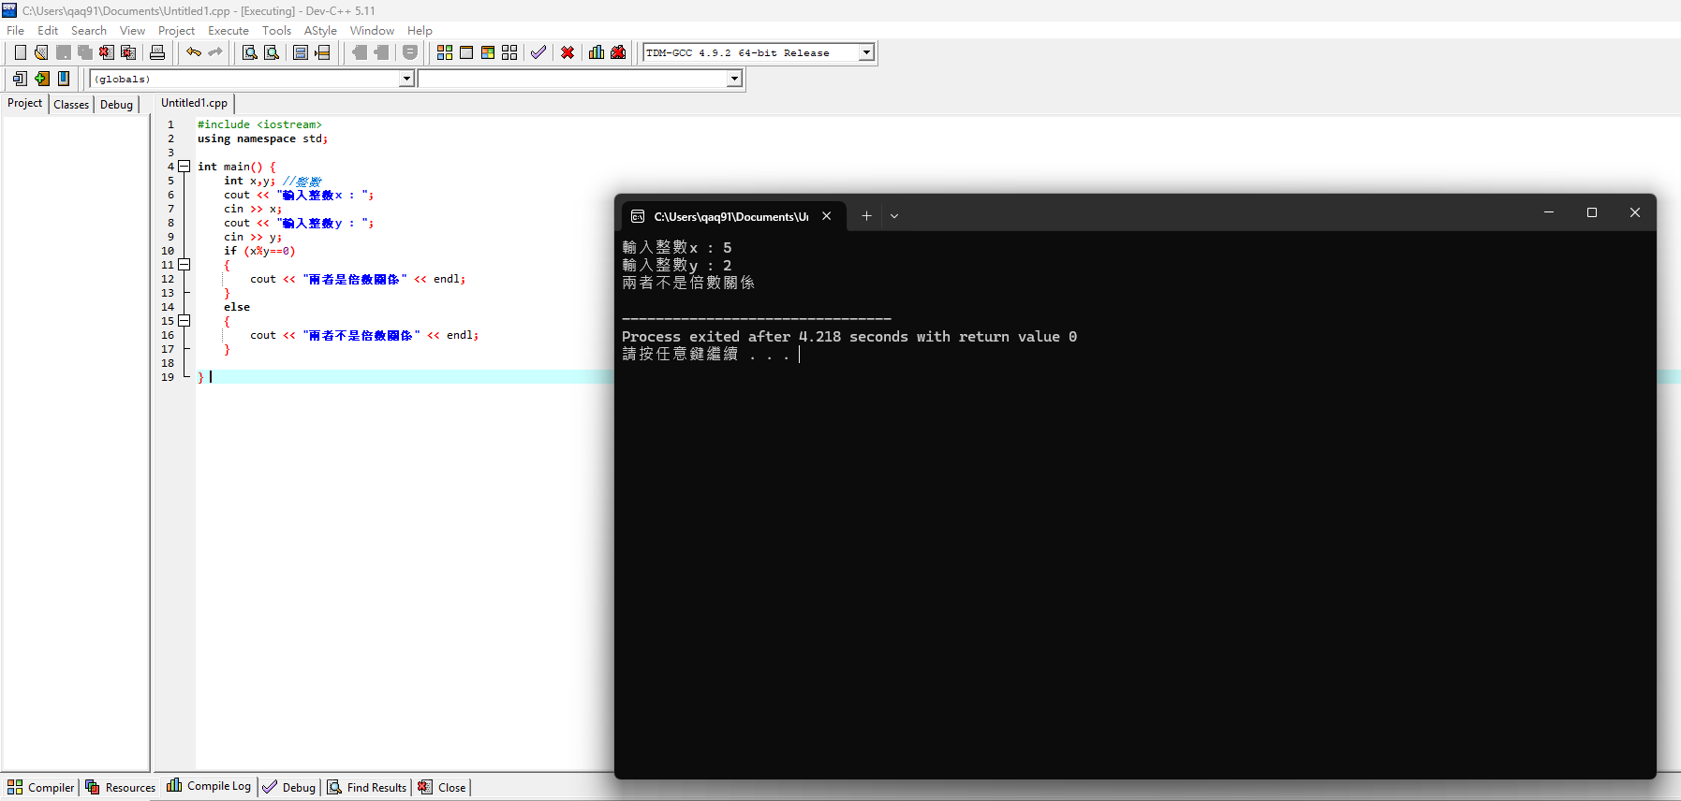

2.27.
Code:
#include <iostream>
using namespace std;

int main() {
char c;
cout << "請輸入字元(ASCII) : ";
cin >> c;
cout << "字元 " << c << " 的整數值是 " << static_cast<int>(c) << endl;

}
Display:
